Aws S3 Assignment 1
Objectives
- Create a bucket in Amazon S3
- Add an object to a bucket
- Manage access permissions on an object and a bucket
- Create a bucket policy
- Use bucket versioning
STEP :- 1 (AWS S3 Dashboard)
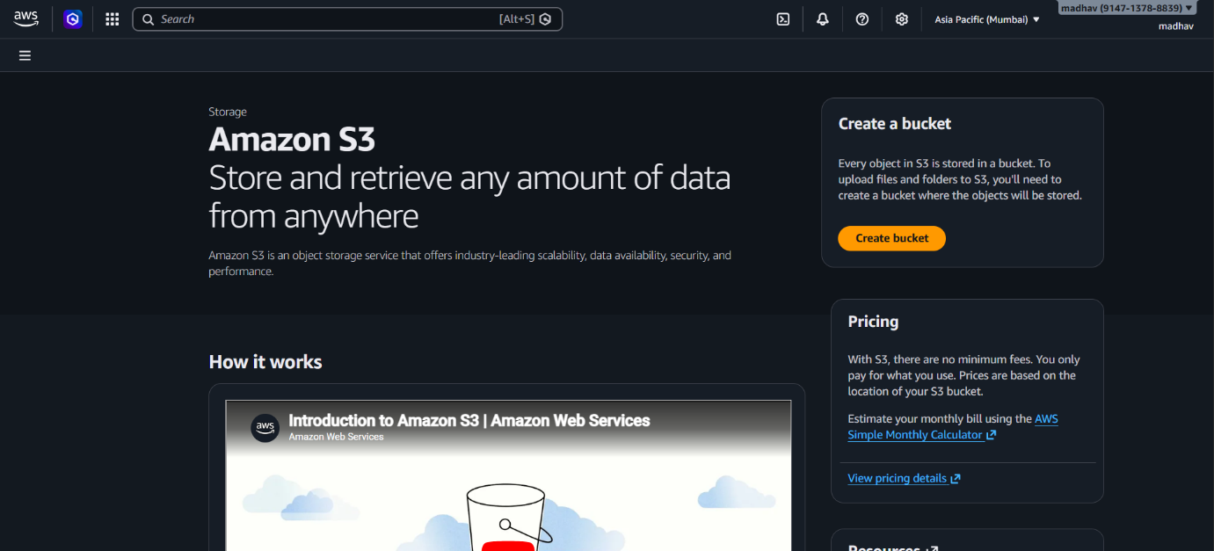
Explanation :- Opened Amazon S3 service from AWS console to manage cloud storage.
This page gives options to create and manage buckets.

STEP :- 2(Creating Bucket (Configuration)
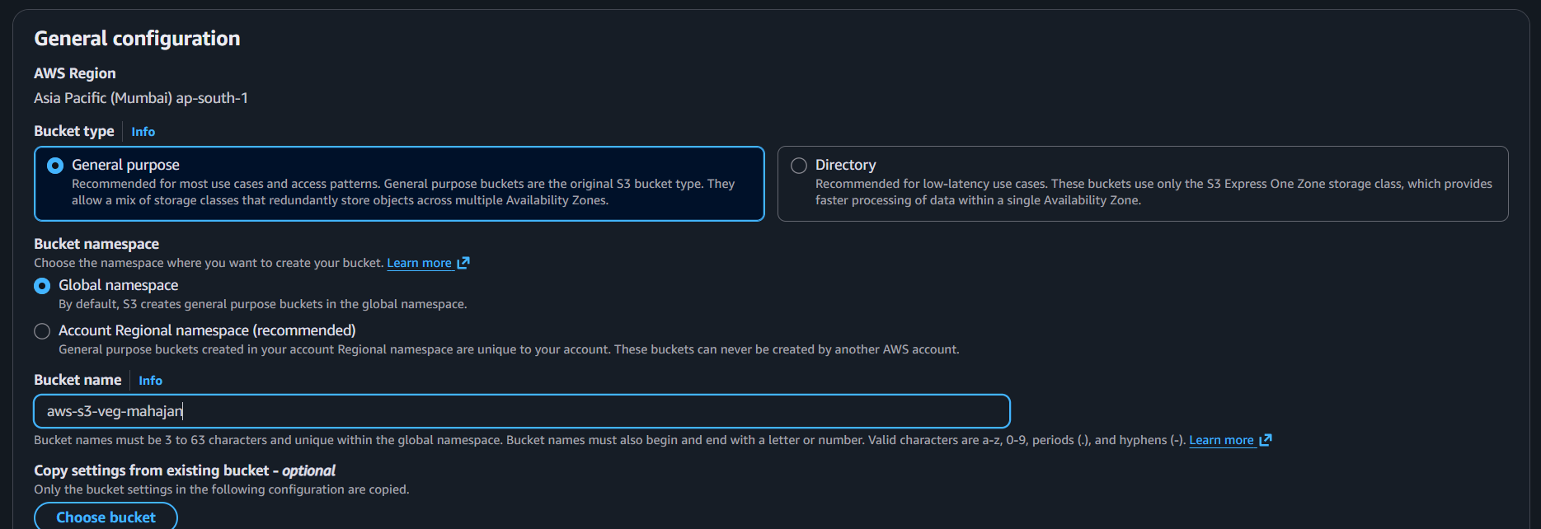
Explanation :- Entered bucket name and selected region (Asia Pacific – Mumbai).
Chose general purpose bucket with default settings for standard storage use.

STEP :- 3(Encryption Settings)
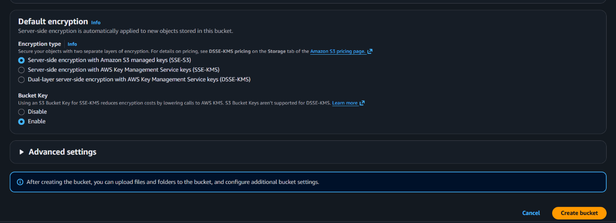
Explanation :- Enabled server-side encryption (SSE-S3) to automatically secure stored data.
This ensures data is protected without manual encryption.

STEP :- 4(bucket successfully created)
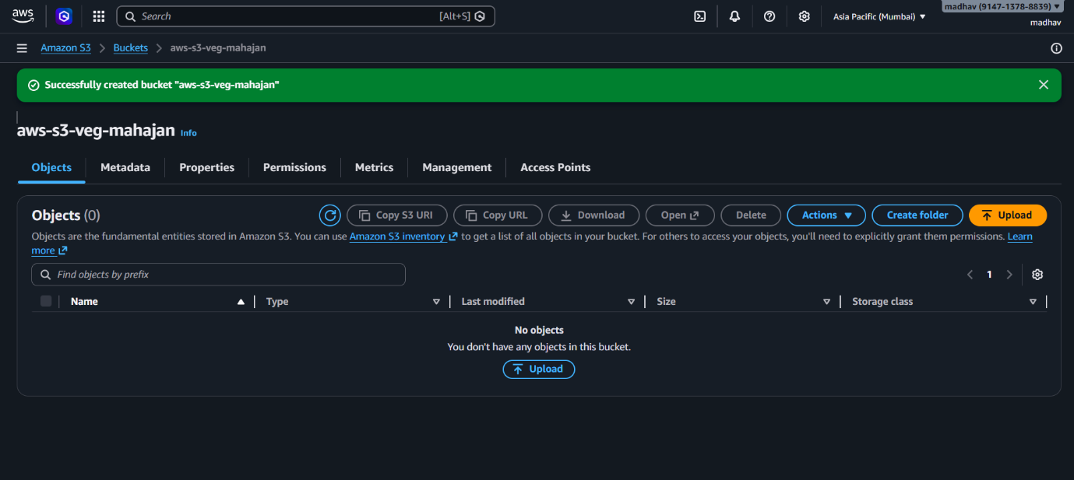
Explanation :- Bucket aws-s3-veg-mahajan was created successfully. Now the bucket is ready to store files (objects).

STEP :- 5(uploading file)
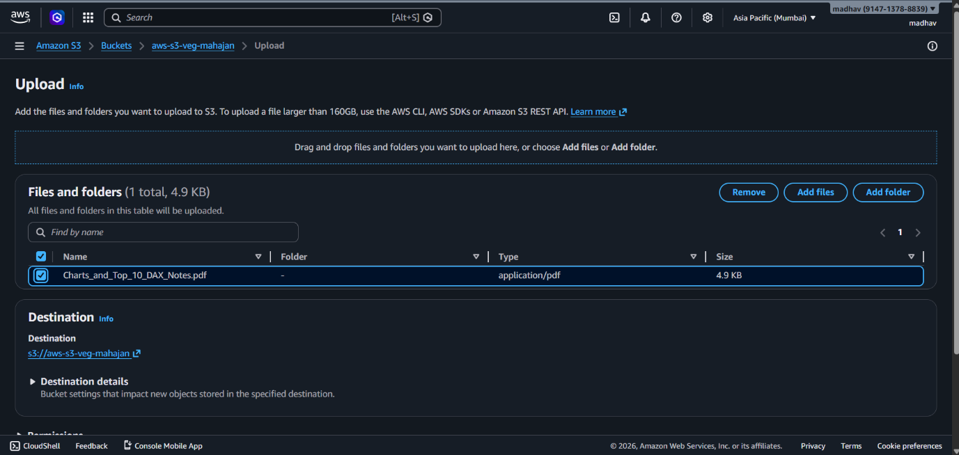
Explanation :- Opened the created bucket and verified it has no objects initially.
Options like upload, create folder, and actions are available.

STEP :- 6(Upload File)
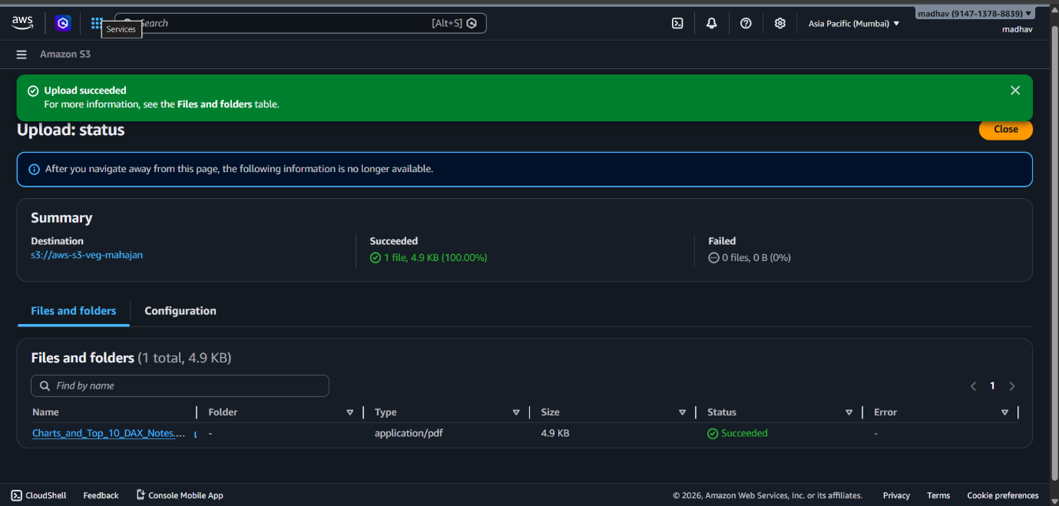
Explanation :- Selected and uploaded the file Charts_and_Top_10_DAX_Notes.pdf into the bucket. Configured destination and confirmed file details before upload.

STEP :- 7 (object overview)
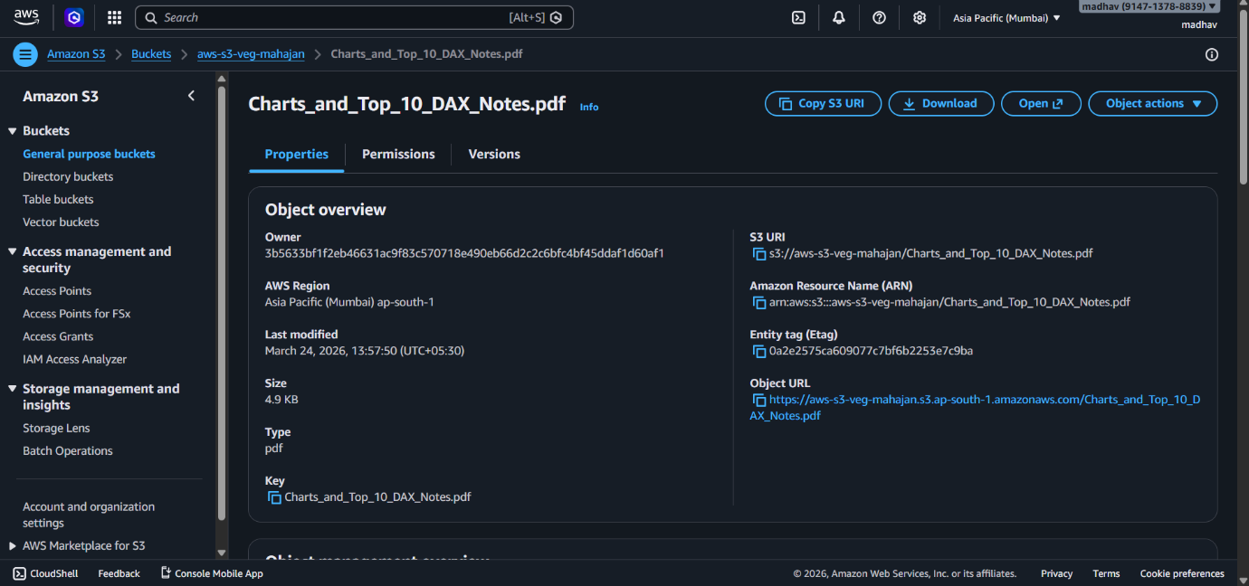
Explanation :- Upload completed successfully with 100% status. The file is now stored in the S3 bucket and accessible.

AWS Services
- Amazon Simple Storage Service
Intended Audience
- Architects
Recommended previous knowledge
This lab follows the Getting Started with Amazon Simple Storage Service (S3) digital course

